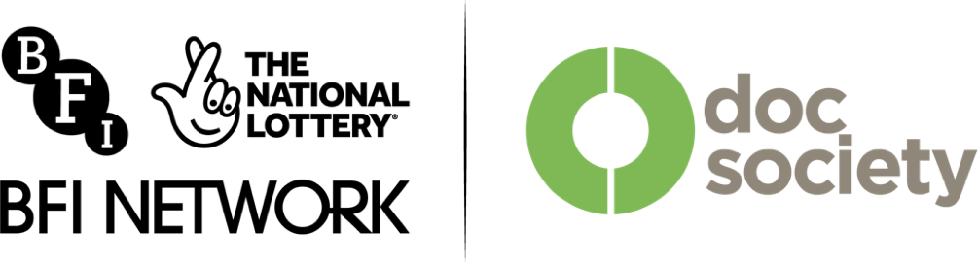
Made of Truth

Easy

Read
BFI Doc Society Short Film
Funding Introduction
Easy Read
This Easy Read information uses easier words and pictures. You may still want help to read it.
links
Some words are in bold - this means the writing is thicker and darker.
These are words that some people will find hard. When you see a bold word, we will explain it in the next sentence.
Blue and underlined words show links to websites and email addresses. You can click on these links on a computer.

Contents
Introduction 4
What the Made of Truth Fund is 5
Who it is for 7
The kinds of films that can get help 10
How to apply for a grant 12
After an application is submitted 19

Introduction
This information tells you about the
Made of Truth: BFI Doc Society Short Film Fund. It is also called the
'Made of Truth Fund'.

It will tell you:
- What it is.

- Who it is for.

- What kind of films it can help.

- How to get help from it.

What the Made of Truth Fund is
The Made of Truth Fund is money you can get to make a short documentary film.
A documentary is a real life story told by real people.
The money can help pay for the costs of making a short documentary.
This money is called a grant.
You will need to apply to get a grant.

If you apply you might not be successful and you might not get a grant.
£5,000
£25,000
15

May

2023
11

June 2023

You can apply for a grant of between £5,000 and £25,000.

You can apply between 4 March 2024 and
4
March 2024
15 April 2024.
15
April 2024

Who it is for
This information will tell you who can apply for Made of Truth: BFI Doc Society Short Film Funding.
You cannot apply on your own as a producer.
You can apply on your own as a director.
You can apply as a team, as a producer and director.
A director finds the story and does interviews with contributors.
They decide how to tell the story.

A producer is a person who helps the director make their documentary.
They organise the money and the crew and help the director tell the story.
Contributors are real people who tell their own story in a documentary.
Interviews are where you talk to a contributor to find something out. You might film this and put it in your documentary.

If you are a director on your own, we will help you to find a producer to work with.
We can only do this if we decide you can have a grant.
The director and the producer must be different people.
18
1

August 2023

The director and producer need to have made films or other storytelling work before.
This other work can be student work.

The director and/or producer must be 18 years old or older to apply.

The director and/or producer must not be full-time students after 1 August 2024.
August

The director and/or producer must live in the UK.

The kinds of films that can get help
This information will tell you what kinds of films you can get the grant for.
The film’s story must be about real people and real things that happened. It cannot be made up.
The film must show real people and not actors. The film can only use actors if it is a reconstruction.
A reconstruction is when actors play real people, acting out something that really happened.

The film can be live-action or animated.
5
to 40
minutes

The film can also be virtual reality or immersive.

The film can be between 5 and 40 minutes long.

The story must be a new idea and not a copy of someone else's work.

The people the story is about must have agreed that you can tell their story.

How to apply for a grant
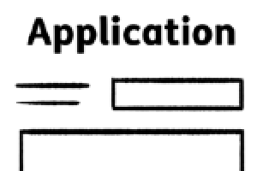
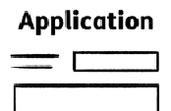
This information will tell you what you need to do to apply for a grant.
Login
Start new
application

You will need to complete an application form to apply for a grant.

The form is on the BFI Doc Society application website.

You will need to make an account to get to the application form.
Go to https://app.docsociety.org/login/
When you have made an account you will be able to see a box, which say 'start new application'.
The application form is sent through the BFI Doc Society application website.
The application form will ask you about:
- Your film’s story.

- Your film’s director and/or producer.

- How you will make the film.

- Where you will make the film.

- Who is going to be in your film.
The application form will also ask you to give examples of your work that you have made before.
You can upload these examples in the application, or write links to other websites.
These examples can be films or other types of art or stories that you have made.

You will need to say how your film meets the BFI Diversity Standards.

Meeting the BFI Diversity Standards means your film includes people from different backgrounds.

It might be in the story your film is telling, the story’s contributors, or the people making your film.
You will need to say how you will make your film in a way that does not damage the environment.

You will need a budget for making your film.
A budget is a list of costs.

You should use the BFI Doc Society Excel template for your budget.

You need a production calendar for your film.
A production calendar is a list of steps for making your film and the dates you will do these steps.
You should use the BFI Doc Society Excel template for your production calendar.
Go to www.docsociety.org/bfi-doc to download the BFI Doc Society Excel template.

You will need to send a treatment or pitch deck - this is a document with images and information about your story.

If your film is an animation you can send us some examples of the style of animation you will be making.

You can answer questions in the application form by:
- Writing the answers.

- Making a video or sound recording of what you would like to say.

After you have sent your application form, you will need to complete an equality monitoring form.
This form asks questions about the backgrounds of the director and/or producer.
This Easy Read information is only a summary of the main information.
If you want to apply for a grant, you should read the full guidelines here: www.docsociety.org/bfi-doc
To hear a recording of the full guidelines, go to www.docsociety.org/bfi-doc

For support with making your application, contact Tape community film and music:
- Phone: 01492 512 109

- Email:
https://tapemusicandfilm.co.uk/ contact/#content

After an application is submitted
This information will tell you what happens to an application after it has been sent.
Application

Received
Submit
You will get an email from BFI Doc Society telling you that your application has been received.
BFI Doc Society will check if your application is eligible - this means whether you are allowed to apply.
BFI Doc Society will check that:
- The right person has applied.

- The film has the right team.
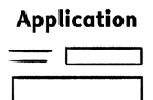
Change
Your application
has not been
accepted because…
BFI Doc Society will also check that the film is the kind of film they can help with.
If your application is not eligible, you will not be able to get a grant. You will get an email to tell you this.
This email will also tell you why your application is not eligible.
If your application is eligible, your application will be read by people from BFI Doc Society and people BFI Doc Society works with.

You might be asked to make changes to your application.
The people reading your application will decide if you can get a grant or not.

You will get an email telling you what the decision is.
The email will tell you what will happen next.
Not all applications will get a grant.

Go to www.docsociety.org/bfi-fund to find out useful information to help you with your documentary film career.

If you have feedback on this Easy Read document please email hello@docsociety.org.
This information is an easy read summary of the Made of Truth: BFI Doc Society Short Film Funding guidelines. The information in this Easy Read summary does not supersede the main funding guidelines.
This Easy Read information has been produced by easy-read-online.co.uk

